A REPORT
on
Hospital Training - II
Submitted in Partial Fulfillment of the requirements
For the Degree of
Bachelor of Pharmacy
By
ABHISHEK MISHRA
B.Pharm. IV Year, VII Semester
Roll No.: 2010180500001
Ambekeshwar Institute of Pharmaceutical Sciences (Lucknow)
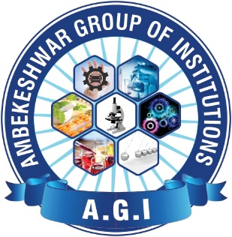
Under the Supervision of
CO-SUPERVISOR
Mr. Devendra Kumar Mishra
Assistant Professor
AIPS, Lucknow
SUPERVISOR
Prof (Dr.) Savita Upadhyay
Director (Pharmacy)
AIPS, Lucknow


to the
Faculty of Pharmacy
Dr. A.P.J. Abdul Kalam Technical University, Lucknow
2023-2024

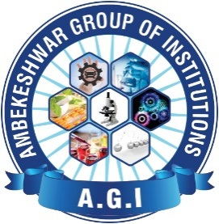

CERTIFICATE OF COMPILATION

This is to certify that this project report entitled “Hospital Training - II” submitted to Ambekeshwar Institute of Pharmaceutical Sciences, Lucknow, is a bonafide record of work done by “Abhishek Mishra” (2010180500001) during the period of his/her study in Bachelor of Pharmacy in the academic year 2023-2024 in the Seventh semester of Fourth Year.

___________________________ __________________________
CO-SUPERVISOR
Mr. Devendra Kumar Mishra
Assistant Professor
AIPS, Lucknow
SUPERVISOR
Prof (Dr.) Savita Upadhyay
Director (Pharmacy)
AIPS, Lucknow

__________________________
EXTERNAL EXAMINER

DATE: ……………………

COPYRIGHT

Declaration by the Candidate

I hereby declare that the Ambekeshwar Institute of Pharmaceutical Sciences, Lucknow shall have the rights to preserve, use and disseminate the report in print or electronic format for academic/ research purpose.

Place: Lucknow Student Name: Abhishek Mishra
Date: Roll No.:2010180500001

DECLARATION BY THE CANDIDATE

This is to certify that the work presented in the report entitled “Hospital Training - II” has been carried out by me for the partial fulfillment of degree of ‘Bachelor of Pharmacy’ under the supervision of Prof (Dr.) Savita Upadhyay and Co-supervision of Mr. Devendra Kumar Mishra of Ambekeshwar Institute of Pharmaceutical Sciences, Lucknow.
The report embodies results of the original work and studies carried out by me and the contents of the report have not formed the basis for the award of any degree/ diploma by any other University or Institution.
I also confirm that all the material which I have borrowed from other sources and incorporated in this report is duly acknowledged.

Place: Lucknow Student Name: Abhishek Mishra
Date: Roll No.:2010180500001

CERTIFICATE BY THE CO-SUPERVISOR

This is to certify that the work presented in the report entitled “Hospital Training – II” submitted by Abhishek Mishra (2010180500001) for the degree of ‘Bachelor of Pharmacy’ has been carried out in the Ambekeshwar Institute of Pharmaceutical Sciences, Lucknow under my guidance.

Place: Lucknow
Mr. Devendra Kumar Mishra
Assistant Professor
AIPS, Lucknow
Date:

CERTIFICATE BY THE SUPERVISOR

This is to certify that the work presented in the report entitled “Hospital Training - II” submitted by Abhishek Mishra (2010180500001) for the degree of ‘Bachelor of Pharmacy’ has been carried out in the Ambekeshwar Institute of Pharmaceutical Sciences, Lucknow under the co-supervision of Mr. Devendra Kumar Mishra, Assistant Professor, Ambekeshwar Institute of Pharmaceutical Sciences, Lucknow.

Place: Lucknow
Prof (Dr.) Savita Upadhyay
Director (Pharmacy)
AIPS, Lucknow

Date:

ACKNOWLEDGEMENT

I would like to express my gratitude towards my parents & member of Ambekeshwar Institute of Pharmaceutical Sciences, Lucknow for their kind co-operation and encouragement which help me in completion of this project.

Being a part of Lucknow's RAM SAGAR MISHR 100-Bed Combined Hospital is a privilege I take great pride in. I learnt a lot during my 45-day training period, and I feel fortunate to have been given the chance to work in this hospital. It was beneficial to apply the theoretical knowledge to real-world situations.

I want to thank Mr. Rajesh Jha sir for giving the training resources and direction I needed throughout the course of my training. I also want to express my gratitude to the employees and trainees who greatly assisted me and without whose help and direction I would not have been able to successfully complete the project.

Place: Lucknow
Student Name: Abhishek Mishra
Date

List of Tables

Table 1. Prescription Abbreviations……………………………………………………22

LIST OF FIGURES

Figure 1. Ram Sagar Mishra 100 Bed Combined Hospital…………………....……....…...01
Figure 2. Ram Sagar Mishra 100 Bed Combined Hospital………………………….….…02
Figure 3. Emergency Ward ………………………………………………………………..04
Figure 4. Ortho and Childcare Ward……………………………………………………….05
Figure 5. Pathology……………………………………………………………………..….07
Figure 6. Male-Female Ward .……………………………………………………….…….11
Figure 7. Department of Radiology………………………………………………………..12
Figure 8. Operations Theatre………………………………………………………………13
Figure 9. First Aid Essentials …………………………………………………………..….15
Figure 10. First Aid Kit…..………………………………………………………..…….…16
Figure 11. Types of Injections…………………………………………………..…………17
Figure 12. Disposal of used needles…………………………………………….…………18
Figure 13. Dressing ………………………………………………………….…………….19
Figure 14. Dressing Technique…………………………………………….………………20
Figure 15.Dispensing Process……………………………………………..……….……....23
Figure 16. Waste Segregation…………………………………………….…………….….25

LIST OF ABBREVIATIONS
OT: Operation Theatre
ED: Emergency Departments
JE: Japanese Encephalitis
HIV: Human Immunodeficiency Virus
CT: Computed Tomography
MRI: Magnetic Resonance Imaging
ER: Emergency Room
CD: Casually Department
RBC: Red Blood Cell
WBC: White Blood Cell
BP: Blood Pressure
GM/DL: Grams per deciliter
CU/MM: cubic millimeter
MG/DL: milligrams per deciliter
MM/HG: millimeters of mercury

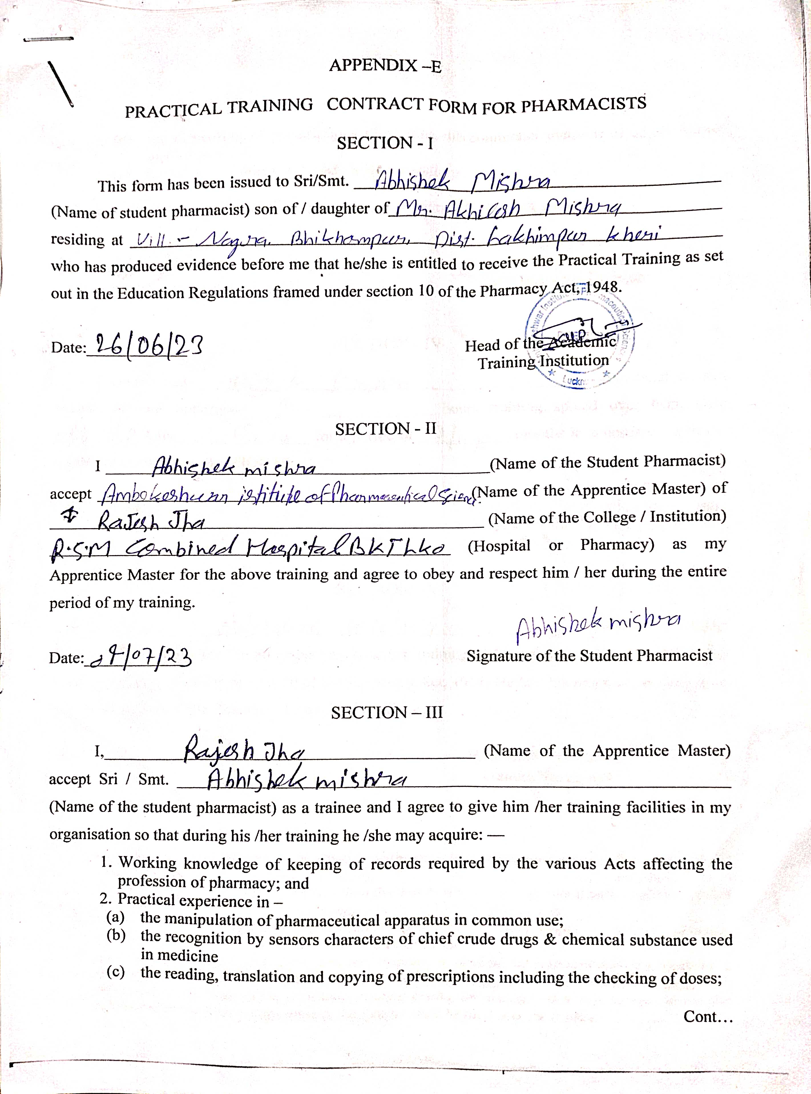
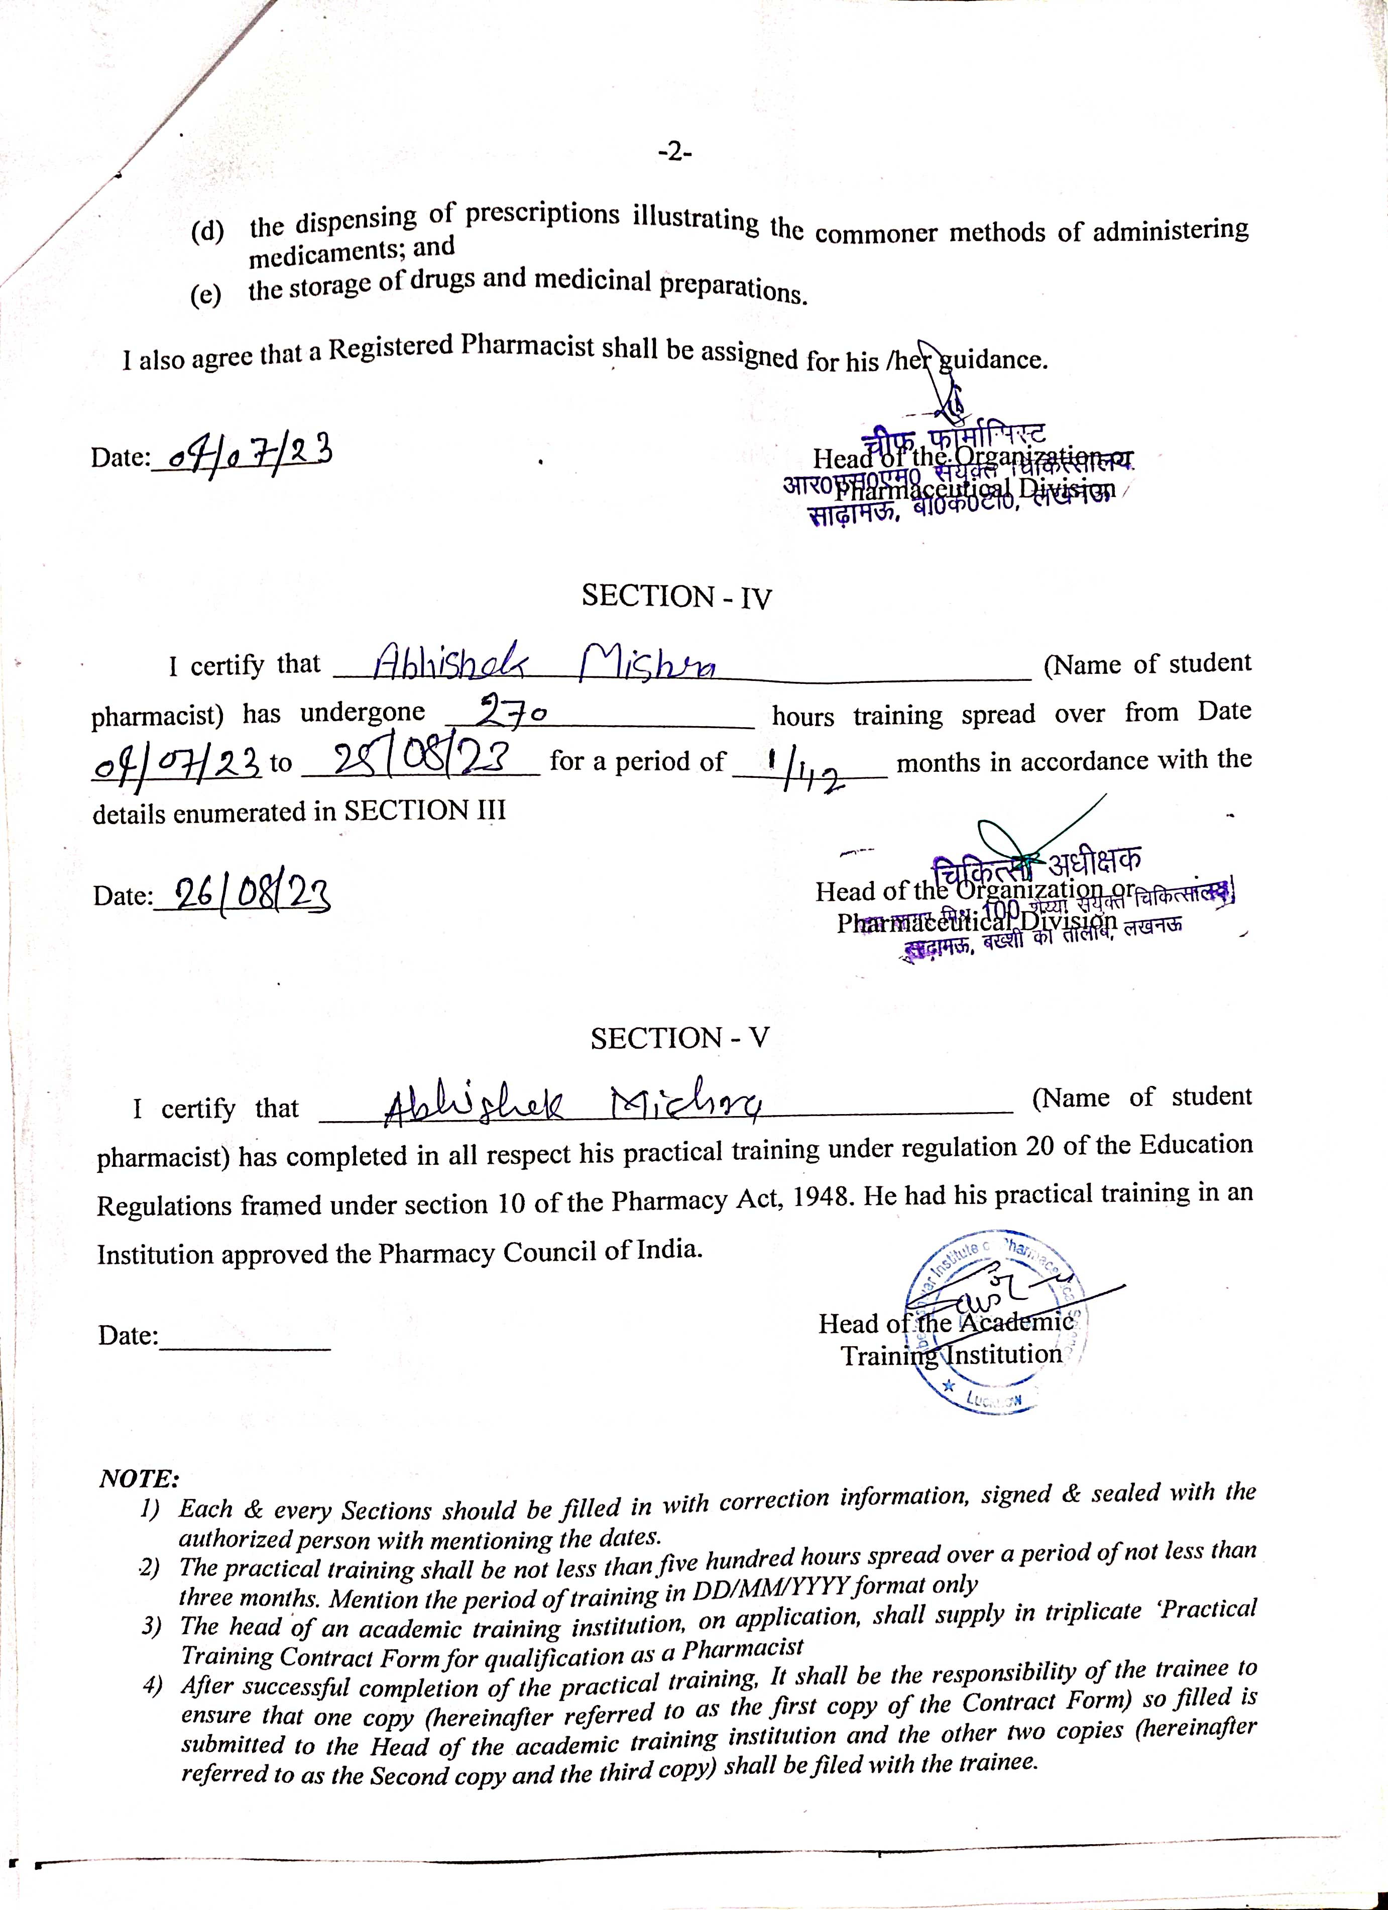
CONTENTS
S. No | Particulars | Page No.
1. | Certificate of Compilation | ii
2. | Copyright | iii
3. | Declaration by the Candidate | iv
4. | Certificate by the Co-Supervisor | v
5. | Certificate by the Supervisor | vi
6. | Acknowledgement | vii
7. | List of Tables | viii
8. | List of Figures | ix
9. | List of Abbreviation | x
10. | Practical Training Contract Form for Pharmacists | xi-xii
11. | Introduction | 1 - 3
12. | Hospital Profile | 4 - 13
13. | Training Imparted | 14 – 25
14. | Observation | 26
15. | Result and Discussion | 27
16. | Conclusion | 28
17. | Bibliography | 29

INTRODUCTION
Introduction
RAM SAGAR MISHRA 100 BED COMBINED HOSPITAL
RSM 100 bed combined hospital is situated in Sadhamau, Bakshi Ka Talab, Lucknow. The hospital is well known foe it’s satisfactory facilities. The hospital has a reputated image in the medical line. The hospital has very hard working medical and non-medical staff who are highly professional and disciplined in their duties. It is authorized by government of India. The hospital has proper sanitation and cleanliness so that the patients do not come in contact of any type of disease.
The hospital and its staff follow very strict rules and regulation. The hospital has many types of clinical and technical facilities so the patients would not suffer from any problem. There are regular health check ups are also done for the staff of the hospital. The hospital also provides residential area for the hospital staff and other members.
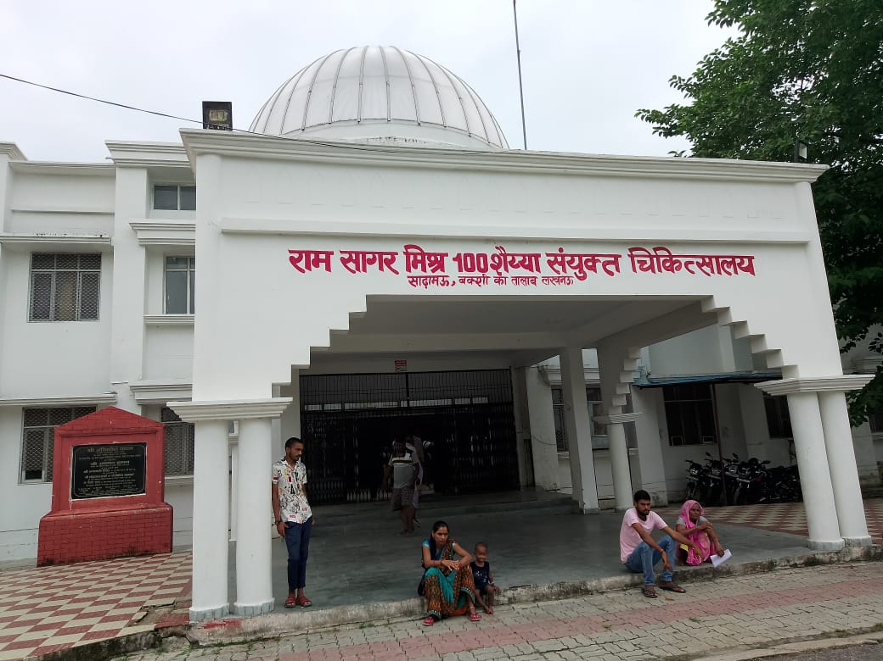
Figure 1- Ram Sagar Mishra 100 Bed Combined Hospital
Introduction
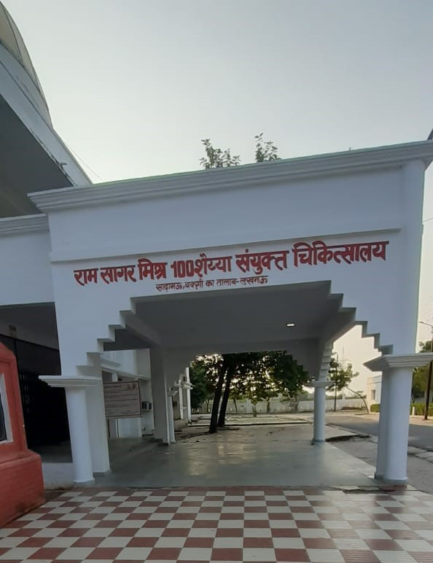
Figure 2- Ram Sagar Mishra 100 Bed Combined Hospital
The hospital has separate departments divided for every different problem. Hospital has proper navigation signs and indicating boards to make the departments easier to find to the patients. The hospital provides proper facilities of 24 hours ambulance service and a medical team available to take care of the patients both day and night.
Introduction
SECTIONS IN RAM SAGAR MISHRA 100 BED COMBINED HOSPITAL
- Emergency Ward
- Ortho and child care ward
- Pathology
- Pharmacy
- Radiology
- OT (Operation Theatre)
- Male-Female ward

EMERGENCY WARD
Hospital Profile
- The emergency department of a hospital is a specially designated area that is equipped with the necessary equipment and personnel to provide high-quality emergency care to patients in need of immediate or acute care, including hospital admission.
- As the initial point of contact, emergency departments (EDs) provide people of almost every age with specialized medical care according to their injuries or sickness.
- The best medical or surgical care is given to patients who are in need of immediate care in EDs, which are a vital part of hospitals and medical practices.
- Emergency departments are well-stocked with the required contemporary equipment and accessories to deliver timely acute, emergency, and trauma care services.
- In a typical ED, nurses, doctors, and physicians collaborate to treat a range of diseases.

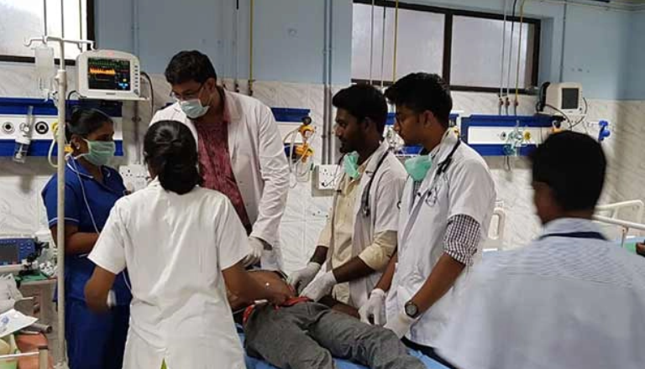
figure 3- Emergency Ward

ORTHO AND CHILD CARE WARD
Hospital Profile
- Orthopaedics is a branch of medicine that specializes in identifying, treating, and preventing skeletal abnormalities, which include problems with the bones, joints, muscles, ligaments, tendons, nerves, and skin.
- The musculoskeletal system is composed of these parts.
- Orthopaedists are involved in all facets of musculoskeletal health care, including medical, physical, and rehabilitative approaches in addition to surgery.
- Orthopaedic doctors treat a wide range of illnesses and injuries, such as fractures and dislocations, torn ligaments, sprains and strains, tendon injuries, strained muscles.
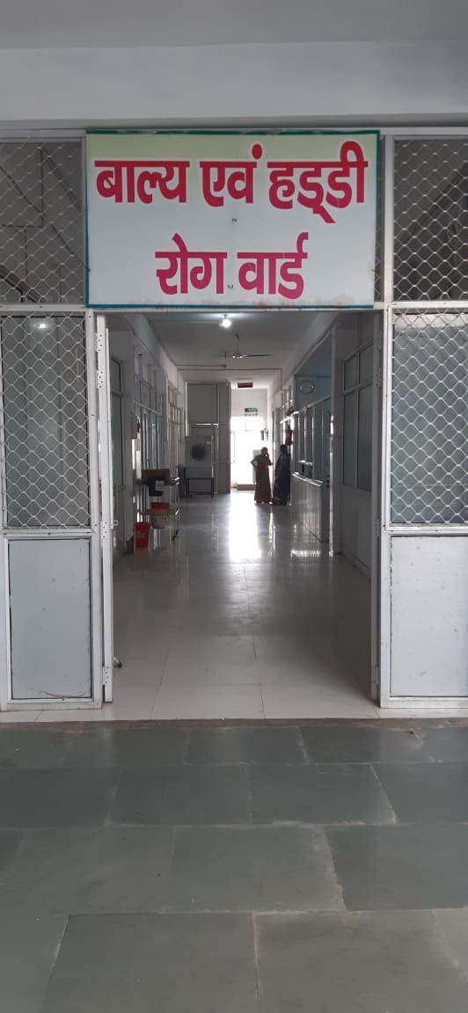
Figure 4- Ortho and Childcare Ward
Hospital Profile
Pediatric Ward
The everyday management of conditions affecting children, from birth to age 18, falls under the purview of the pediatric ward personnel.
- Children and adolescents who are ill and require specialized care are treated in the child care ward.
- The majority of the child patients who come for treatment are suffering from JE (Japanese encephalitis), and there are specialized doctors and nurses available for treating a variety of disorders in children as well as for giving timely injections or doses.

PATHOLOGY
Hospital Profile
- For the purpose of studying and diagnosing disease, pathology entails the examination of tissues, organs, body fluids, and corpses.
- It also includes the closely linked scientific study of disease processes, in which the causes, mechanisms, and severity of the disease are evaluated.
- The great majority of cancer diagnoses are made by pathologists, who have specialties in a variety of disorders, including cancer.
- Anatomical pathology and clinical pathology are the two main subspecialties of general pathology.
- In everyday medical practice, general pathology focuses mostly on examining known clinical abnormalities that are indicators or precursors for both infectious and non-infectious disease.
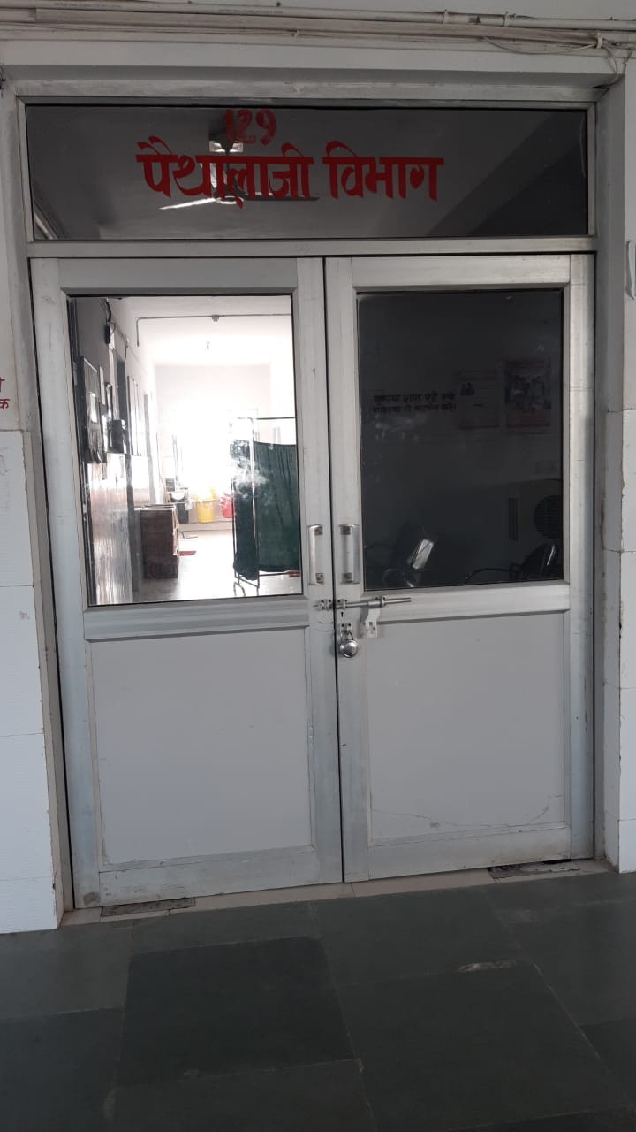Figure 5- Pathology
PHARMACY
Hospital Profile
- Pharmacy is available in the hospital that have stock of a large range of medications.
- It typically provides medications for the hospitalized patients only and are not retail establishments.
- Some hospitals do have retail pharmacies with in them, which sell over the counter as well as prescription medications to the public, but these are not the actual hospital pharmacy.
- It also helps patients to understand their medications and how to take them.
- Pharmacists acquire expertise in the storage of data, distribution, and inventory control functions, and the management of data for drug histories, patient records, quality assurance programs, and drug information services.
The primary functions of Hospital Pharmacy are:
- Selection of reliable suppliers
- Storing and dispensing of Drugs
- Maintenance of manufacturing records
- Quality control of purchased and manufactured products
- Expecting and knowing the hospital demands

Objectives Of Hospital Pharmacy
1. To professionalize the functioning of the pharmaceutical services in hospital.
2. To ensure availability of the required medication at an affordable cost at the
required time.
3. To plan, organize and implement the policies of the pharmacy.
4. To perform functions of management of material, purchase, storage of essential medicines.
5. To maintain strict inventory of all items received and issued.
6. To counsel the patient, medical staff, nurses and others involved in patient care on the use of drugs, possible side effects, toxicity, adverse effects, drug
interactions etc.
7. To serve as a source of information on drug utilization.

Five Principles of Pharmacy
1. FIFO – First In First Out
2. LASA – Look Alike Sound Alike
3. LIFO – Less Life In First Out
Hospital Profile
4. VED – Vital Essential Desirable
5. GAAP – General Accounting Principles In Pharmacy

Care While Storing The Medicine
1. Narcotics drugs in safe custody (double lock).
2. Safe Refrigeration of medicines requiring certain temperature.
3. Have a ‘Master Chart’ at the entrance of medical store, showing the layout of racks, almirahs in store with list of medicines.
4. Display Emergency Drug List.
5. Display Essential Drug List.
6. Drug Formulatory of EDL on display (circulate to all departments).
7. Display expiry drug list mentioning date of expiry, batch number and quantity of the drug.
8. Do not keep drugs with direct contact of floor or direct sunlight near the window.
9. Keep inflammable drugs/ chemicals separate and away from other drugs.

Quality Tool For Improvement Of Process Of Purchasing And Maintaining Stock Of Drugs As PEREDL List

PDCA CYCLE

PLAN
- Training should be organized for staff to operate online system.
- Availability of budget to purchase drugs in case of shortage or delay.
- Staff as per requirement to avoid the overload.

DO
- Impart Training.
- Apply for budget to purchase medicine from local store.
- Manage timely order and transportation of drugs.
CHECK
Hospital Profile
- Availability of drugs.
- Time management of placing order and transportation of drugs.

ACT
- Periodic training.
- Maintaining adequate stock of drugs.

END RESULT: Drug shortage will be handled by this approach.

MALE-FEMALE WARD
Hospital Profile
A general ward is a large room, where people who need medical treatment and not suffering from any chronic disease stay.
FEMALE GENERAL WARD
The care of female patients is the only focus of this ward. The everyday management of acute and chronic medical diseases, including malaria, hypertension, diabetes mellitus, HIV, and gastrointestinal conditions, falls under the purview of nurses. Direct admissions from the emergency room are made to the unit. For patients who may be experiencing acute respiratory distress, the unit offers attachments for oxygen therapy, suction, and nebulizing.
MALE GENERAL WARD
The male emergency ward is where admissions, monitoring, and oxygen therapy are handled. Staff members deal with illnesses like malaria, high blood pressure, diabetes, strokes, and renal failure, among others. A nurse's duties also include participating in ward rounds with doctors and physician assistants, vital sign assessment and recording, medicine delivery, health education, wound treatment, and ward rounds.

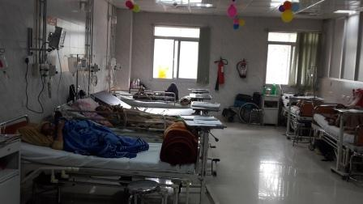

Figure 6 – Male-Female Ward

RADIOLOGY DEPARTMENT
Hospital Profile

Imaging is used in this medical discipline to identify and treat disorders that are visible inside the body. To diagnose and/or treat disorders, radiologists use a number of imaging modalities, including X-rays, ultrasound, computed tomography (CT), and magnetic resonance imaging (MRI).

X-rays: used to see through tissue to check for cavities, fractures, and foreign objects. may be combined with contrast chemicals to produce a live motion image, such as in angiography or fluoroscopy to image the blood arteries or the digestive system.

CT (computed tomography) offers cross-sectional views (slices) of the body that help locate and diagnose disease.

High frequency sound is used in ultrasound. This procedure is frequently utilized for patients with abdominal, vascular, or musculoskeletal disorders as well as in obstetrics, gynecology, and pediatrics.
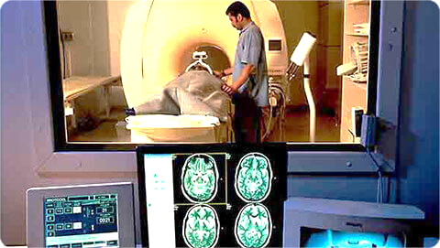

Figure 7 – Department of Radiology

OPERATIONS THEATRE
Hospital Profile
Certain surgical treatments, which include surgeries involving cSutting into and working inside a patient's body, are performed in an operating room. Complex procedures can take a long time.
The stages of an operating theatre;
Operations normally take place in four stages, which all require specialist staff:
1. Pre-operative stage is when patients are informed about and prepared for the operation about to take place, by restricting their diet.
2. Anaesthetic stage is when the patient is either ‘put to sleep’ under general anaesthetic or has part of their body numbed under local anaesthetic.
3. Surgical stage is when the operation is performed in the operating theatre
4. Recovery stage is when the patient is transferred to a ward for further care and treatment.
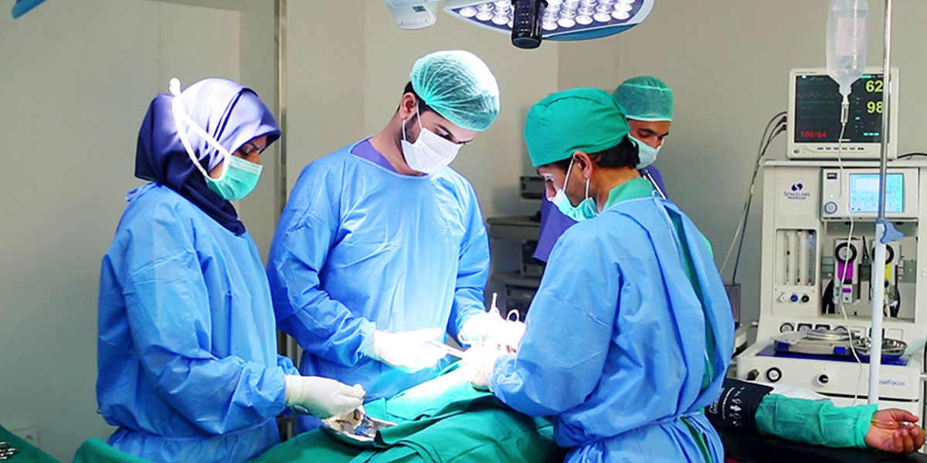

Figure 8 - Operations Theatre

HOSPITAL INTERNSHIP ACTIVITY
Training Imparted
Hospital Internship Activities include –
1. First Aid Treatment
2. Injections
3. Dressing
4. Prescription
5. Dispensing Procedure
6. Diagnostic Report
7. Patient Observation Chart

FIRST AID TREATMENT
Training Imparted
First Aid is the term for providing emergency medical care to a sick or injured person until the illness or damage is properly treated. It often consists of a set of easy, possibly life-saving actions that anyone can learn to undertake with the bare minimum of tools.

First aid procedure
- Laying the person flat.
- Opening their airway and assessing for breathing.
- Loosening any restrictive clothing around their neck or their waist.
- Consciousness is usually quickly regained with these first aid measures.
- If the person remains unconscious, check for breathing again and, provided that they are breathing, put them into the recovery position.
- Call an ambulance and refer for further assessment as needed.

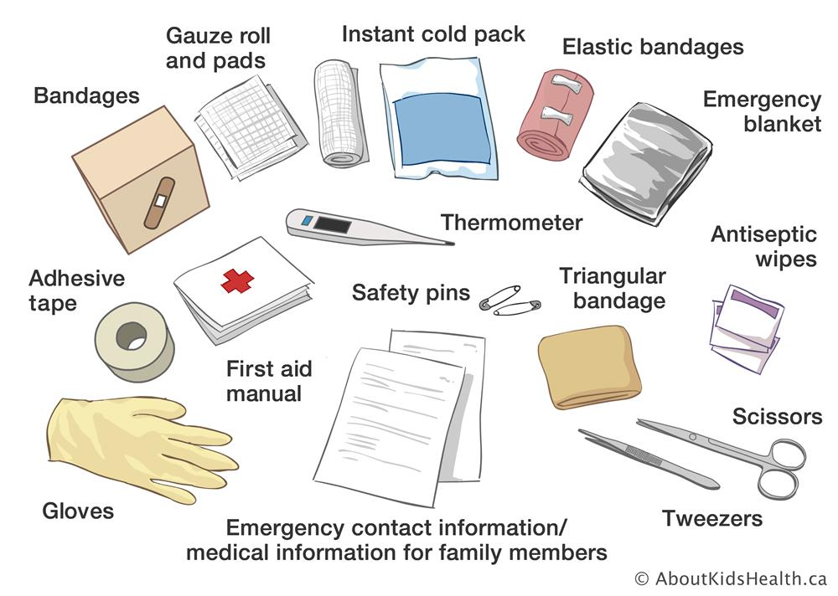

Figure 9 - First Aid Essentials
The person should be encouraged to use the principles of 'paying the PRICE' and 'avoiding HARM' for the first 48-72 hours after the injury.
Training Imparted
- Protection: from further injury.
- Rest: for the first 48-72 hours after injury, activity should be avoided. The use of crutches can be considered for lower limb injuries.
- Ice: a specialized ice pack wrapped in a cloth can be applied for 15-20 minutes every 2-3 hours for the first 48-72 hours after injury.
- Compression: helps to reduce swelling. An elastic bandage can be applied around the affected limb. Remove at night. Ensure that the bandage is not too tight.
- Elevation: as far as possible, elevate the injured area above the level of the heart for the first 48-72 hours, ensuring that it is comfortably supported.

Avoid HARM for the first 72 hours after the injury:
- Heat: including heat packs, hot baths, saunas.
- Alcohol: this can increase swelling and bleeding.
- Running: or other forms of exercise.
- Massage: this can increase swelling and bleeding.

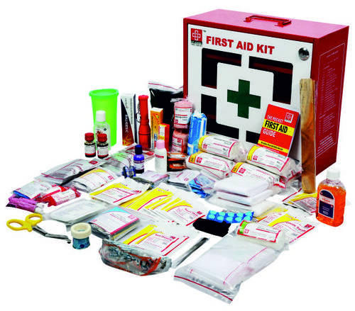
Figure 10 - First Aid Kit
METHODS OF INJECTIONS
Training Imparted
An injection is a way of administering a liquid to a person using a needle and syringe.
The four most frequently used types of injection are:
- Intravenous (IV) injections An IV injection is the fastest way to inject a medication and involves using a syringe to inject a medication directly into a vein.
- Intramuscular (IM) injections IM injections are given deep into a muscle where the medication is then absorbed quickly by surrounding blood vessels.
- Subcutaneous (SC) injections SC injections are injected into the innermost layer of the skin called the subcutis or hypodermis, which is made up of a network of fat and collagen cells.
- SC injections are also known as ‘subcut’ or ‘SQ’ injections.
- These injections work more slowly than an IV or IM injection because the area does not have such a rich blood supply.
- Intradermal (ID) injections ID injections are given directly into the middle layer of the skin called the dermis.
- This type of injection is absorbed more slowly again than IV, IM or SC injections.
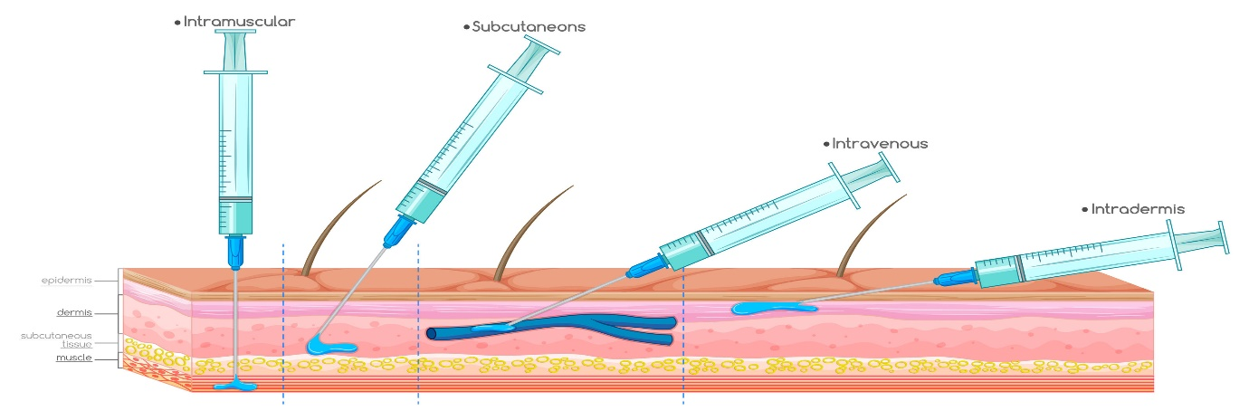
Figure 11 - Types of Injections
Technique of needle use
Proper needle use is important to perform injections safely, which includes the use of a new, sterile needle for each injection. Needles should not be shared between people, as this increases risk of transmitting blood-borne pathogens. In addition, it is not recommended to reuse a used needle to pierce a medication bag, bottle, or ampule designed to provide multiple doses of a medication, instead a new needle should be used each time the container must be pierced. Aseptic technique should always be practiced when administering injections. This includes the use of barriers including gloves, gowns, and masks for health care providers. It also requires the use of a new, sterile needle, syringe and other equipment for each injection, as well as proper training to avoid touching non-sterile surfaces with sterile items.
Training Imparted
Disposal of used needles
Used needles should be disposed of in specifically designed sharp containers to reduce the risk of accidental needle sticks and exposure to other people. In addition, a new sharp container should be begun once it is 3⁄4 full. A sharps container which is 3⁄4 filled should be sealed properly to prevent re-opening or accidental opening during transportation.

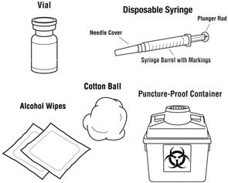
Figure 12 - Disposal of used needles

Training Imparted
DRESSING
- A dressing is applied to a wound to protect it, stop infection, and promote healing. A dressing should have a safety margin of approximately 2.5 cm on all sides beyond the wound and be big enough to completely cover the wound.
- A sterile dressing can be used to stop significant wound bleeding or to soak up any discharge from a smaller wound.
- Where a wound is present, a bandage is utilized along with a dressing. A dressing is held in place with the help of a roller bandage.
- A triangular bandage can be used as a pad to stop bleeding or as an arm sling. It can also be used as temporary padding over an injured bone or joint or to support or immobilize one.

The seven most commonly used wound dressings-
1. Hydrocolloid- Hydrocolloid dressings are impermeable to bacteria, which is what makes them so effective at preventing infections. They are also long-lasting, biodegradable, and easy to apply.
2. Hydrogel- It can be used for a range of wounds that are leaking little or no fluids. Hydrogel can also be used for second-degree burns and infected wounds.
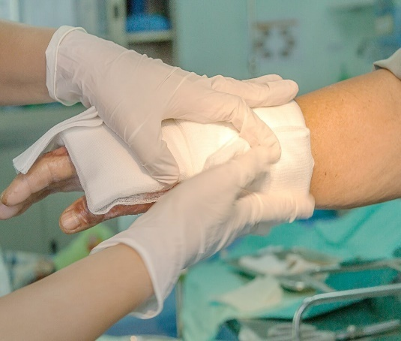
3. Alginate- These dressings absorb excess liquid and create a gel that helps to heal the wound or burn more quickly. These dressings require changing around every two days, sometimes more, due to the amount of liquid that they absorb and the nature of the wound. Changing them too often could cause too much dryness or could lead to bacteria penetrating the wound. These should only be used for wet wounds with high liquid drainage; else they can hinder healing by drying out wounds too quickly.
Training Imparted
4. Collagen- Collagen dressings can be used for chronic wounds or stalled wounds, pressure sores, transplant sites, surgical wounds, ulcers, burns, or injuries with a large surface area. Collagen dressings encourage the wound healing process in a range of ways; these include by helping to remove dead tissue, aiding the growth of new blood vessels, and helping to bring the wound edges together, effectively speeding up healing.
5. Cloth dressings- These are the most commonly used dressings, often used to protect open wounds or areas of broken skin. They are suitable for minor injuries such as grazes, cuts or areas of delicate skin.These dressings come in all shapes and sizes, from small coverings for fingers to larger ones for wounds across wider areas of the body. As well as pre-cut dressings, these also come in a roll option that is made to be cut to size.
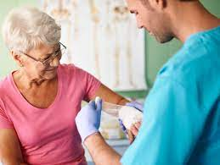
Figure 14 - Dressing Technique
SOME PRESCRIPTION ABBREVIATIONS
Training Imparted
a.c | Before meal
a.m | Morning
Aq. | Water
Aurist | ear-drops
b. | Twice
b.i.d | twice a day
Caps | a capsule
Charts | Powder papers; divided powders
c.c. | With food; with meals
H | At the hours of
H.s. | At bedtime
n. | At night
Narist. | Nasal drops
o.m. | Every morning
q.i.d | Four times a day

Table 1 - Prescription abbrevations

DISPENSING PROCESS
Training Imparted
The consistent, repeated use of good dispensing procedures is vital in ensuring that errors are detected and corrected at all stages of the dispensing process. The term dispensing process covers all activities involved, from receiving the prescription to issuing the prescribed medicine to the patient.
The development and use of written standard operating procedures (SOPs) for the dispensing process will improve consistency and quality of work and can be used for training and reference. The framework for such SOPs may be based on the six major areas of activity:
1. Receive and validate the prescription
2. Understand and interpret the prescription
3. Prepare and label items for issue
4. Make a final check
5. Record the action taken
6. Issue medicine to the patient with clear instructions
and advice

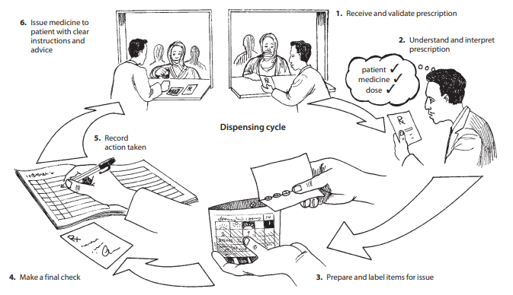
Figure 15 - Dispensing Process
PHYSIOLOGICAL PARAMETERS
Training Imparted
1. pH of Blood:- 7.35-7.45
2. Hemoglobin
a. 13-18gm/dl in adult male
b. 12-16gm/dl in female
c. 9-15gm/dl in children
3. RBC Count (Red Blood Cell)
a. 4.5-5.5 microliter in male
b. 3.5-5.5 microliter in female
4. WBC Count (White Blood Cell) 4000-11000/cu mm
5. Platelet or Thromocytes count 1,50,000-4,00,000
6. Clotting time 2-6 min
7. Bleeding time 2-5 min
8. Blood Sugar Level 80-120mg/100ml
9. Blood cholesterol 150-250mg/100ml
10. Blood urea 8-26 mg/dl
11. Creatinine 1-2mg/dl
12. Sperm count 60-150 million per ml
13. Heart rate 70-80 beats/min
14. Blood pressure 80-120mm /Hg

WASTE MANAGEMENT IN HOSPITALS
Training Imparted
Medical waste, including infectious materials, chemicals, outdated medications, radioactive materials, and sharps (used needles, lancets, etc.), can be dangerous and even deadly if improperly disposed of or managed.

Color-Code Containers and Waste Bins
Medical waste comes in many different forms, all of which must be disposed of. Every medical waste item has a unique identification number and is disposed of using a distinct technique. Sorting medical wastes according to kind makes it easier to make sure that each one is disposed of, moved, and destroyed properly. In hospitals, waste bin color coding makes it simple for medical staff to separate garbage and identify which waste belongs in which container, helping to reduce problems brought on by careless or inappropriate disposal.
It is ideal to separate medical garbage as soon as possible to prevent harmful hospital waste from being combined with normal trash.

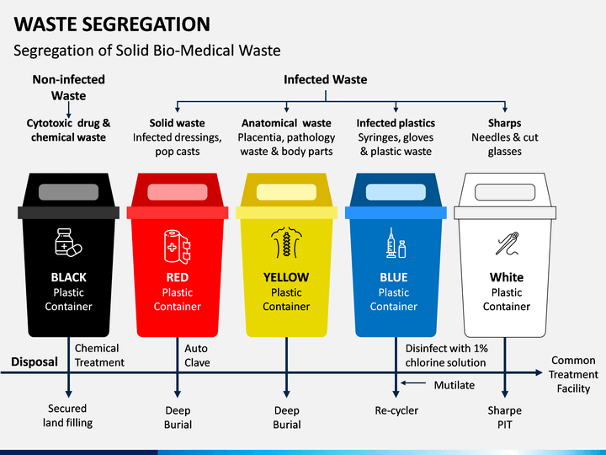
Figure 16 - Waste Segregation
These are easy to use and they help get more things done in shorter period of time.
Training Imparted
Monitoring checklists also help ensure that people get their daily, weekly, and monthly task done on time.
These are just some of practices that can be done to ensure proper medical waste management in the healthcare facility:
- It lessens the danger of unintended harm to personnel, patients, visitors, and the general public as well as the spread of infectious diseases.
- It lessens the chance that chemicals or microorganisms will contaminate the soil or ground water.
- It contributes to the creation of an aesthetically pleasant environment; it draws fewer insects and rodents and does not attract animals.
Observation
OBSERVATION
- As a result, I arrived to the opinion that the hospital is a setting where individuals of all types go to convey their issues, which they trust the medical team to solve.
- The hospital can function by keeping a clean environment.
- The doctors and medical personnel all handle the patients in a hostile and humorous manner while paying attention to their issues.
- Each department has a unique manner of working, and at the end of the day, they all finish the job.
- Patients are treated with respect and immediately begin receiving their shots or medications.
- They know that the nursing staff would always take care of their needs this method should be used by hospitals.

RESULT AND DISCUSSION
Result And Discussion
According to the university's curriculum, a 45-day hospital training program has been completed. Work has been done in various hospital departments, including emergency, IPD, OPD, dispensary, and shop.
The hospital is the most fascinating section of the university curriculum since it gives us a great opportunity to learn and apply all of our information.

CONCLUSION
Conclusion
The training in a hospital leads us to the conclusion that the training in a hospital was really necessary since it not only helped us understand how a hospital operates, but it also helped me learn the fundamental functions of it, such as first aid care, how to administer an injection, and drug dispensing, etc.
The inference made is that I have finally understood the crucial role that hospitals play in people's lives and that hospital staff members are obligated to do everything in their power to save patients.
Ram Sagar Combined Hospital's generosity towards humanity and to their service is further demonstrated by the fact that they only receive 1 rupee every patient.
BIBLIOGRAPHY
Bibliography

Pharmacy Department- https://www.grafiati.com/en/literature/pharmacy/
Emergency Department- https://en.wikipedia.org/wiki/Emergency_department
OPD- https:// ww.vedantu.com /full-form/opd-full-form
General Ward- https:// ww.byjus.com General_Ward
Pathology Lab- https://www.healio.com
Dressing department- https://www.ncbi.nlm.nih.gov/pmc/articles/PMC4662938/
Diagnostic report- https://www.ibm.com/docs/en/tnpm
Dispensing- https://www.bccnm.ca/RN/learning/medication/Pages/dispensing.aspx
Injection- https://www.ncbi.nlm.nih.gov/books/NBK556121/
Prescription- https://www.pharmaguideline.com
Pediatricward- https://www.sciencedirect.com/topics/nursing-and-health-
Male female ward- https://www.mmh.mw/male-and-female-ward-and-surgical-services/
Radiology department- https://www.sciencedirect.com/topics/nursing-and-health-
Operation theatre- https://en.wikipedia.org/wiki/Operating_theater

